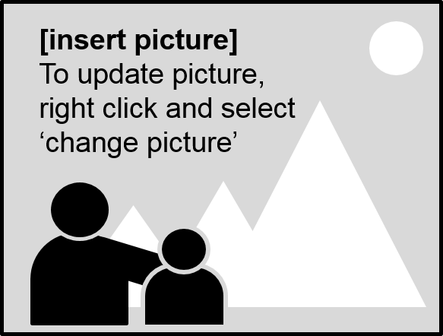

**[insert message]**

Your message in this text box

**[insert school logo]**

Paste and resize logo image to fit inside bubble

[